AUTHOR

|  |  |  |  |  |  |  |
| --- | --- | --- | --- | --- | --- | --- |
| **Department** |  | **Signature** |  | **Print Name** |  | **Date** |
| R&D |  |  |  | Douglas Tenney |  |  |

SIGNATURES

|  |  |  |  |  |  |  |
| --- | --- | --- | --- | --- | --- | --- |
| **Department** |  | **Signature** |  | **Print Name** |  | **Date** |
| R&D |  |  |  |  |  |  |
| Mktg |  |  |  |  |  |  |
| SQA |  |  |  |  |  |  |

Revision History

|  |  |  |  |  |  |  |
| --- | --- | --- | --- | --- | --- | --- |
| **Rev.** |  | **Date** |  | **Initials** |  | **Description** |
| A |  | 16-Oct-2009 |  | DAT |  | Initial Release |
| A.1 |  | 24-Jan-2019 |  | DAT |  | Update Format |
| A.2 |  | 11-Jul-2019 |  | DAT |  | Add Serial Number Support |
| A.3 |  | 22-Jul-2019 |  | DAT |  | Added Software Upgrade Cancelled |
| B |  | 26-Sep-2019 |  | DAT |  | Updated to Revision B, content is identical to Revision A.3 |

Glossary

**DII EIP platform**

A hardware and software platform architecture that is used for implementing the DYONICS™ Power II EIP Control System. Contains USB port(s) for upgrade purposes.

**Motor Controller**

The system processor subcomponent that is based on a Motorola DSP56F8357 processor. The software for this module is comprised of:

* Factory loaded boot software (not field upgradeable)
* Application software (field upgradeable) (a.k.a. **Motor Controller Software**)

**System Controller**

The system processor subcomponent that is based on an Atmel ARM-based CPU module. The software for this module contains the following pieces of software:

* Factory loaded boot software (not field upgradeable)
* Application software (field upgradeable) (a.k.a. **System Software**)

**USB Flash Drive**

The delivery medium for software upgrades. Formatted as a Win32 file system.

**Upgrade File**

File on the USB Flash Drive that contains upgrade information in a custom format. This file must be named “NextGen.upg” and reside in the root directory of the USB Flash Drive.

**buildupgrade**

Console application on a host PC that is used to create an upgrade file from software for the Motor Controller and the System Controller.

**Main Application**

End user application that runs on the Dyonics II EIP platform e.g. the pump application or the shaver application

Table of Contents

1 Introduction 4

2 Creating an Upgrade File 5

2.1 Option Combinations And Restrictions 8

2.2 Changing Version Numbers 8

3 Layout of the Upgrade File 9

3.1 Upgrade File Limitations 10

4 System Self Repair 11

5 Upgrading a System Using an Upgrade File 16

5.1 Serial Number Screens 17

5.2 Initiate Software Upgrade Screens 22

5.3 System Software Screens 25

5.4 Motor Controller Software Screens 32

5.5 Final Screens 38

5.6 Top Level Error Screens 42

5.7 Example Screen Sequences and User Actions 42

6 References 43

# Introduction

The DII EIP platform is designed for field software upgrades via a USB Flash Drive connected to one of its USB ports. This document describes:

* How to create an Upgrade File on a host PC
* The layout of the Upgrade File
* Using the Upgrade File To Upgrade A System
* System Self Repair

All screen shots in this document are given for the English language only. Every screen has been translated to the following languages:

* English
* German
* Italian
* Spanish
* French
* Swedish
* Danish
* Dutch
* Portuguese
* Norwegian

# Creating an Upgrade File

The *buildupgrade* tool is used to create an Upgrade File from various components. The executable must be run in the VSS directory **R_D\DII-EIP\Software\Common Software\Tools\BuildUpgrade**, because it looks for some default run-time files in that directory. It outputs informative messages, warnings and errors on the console (DOS window). The exit status to the shell is 0 if it succeeds with no errors.

The following diagram shows a process overview of the tool:



This tool takes the following arguments, all arguments are case sensitive:

|  |  |  |  |
| --- | --- | --- | --- |
| Option | Default Value | Must be specified? | Description |
| -splash <pcSplashFile> | None | Yes | <pcSplashFile> is the pathname of a bitmap file (.bmp) to use for the splash screen of the application. Not all bitmap formats are supported, only those with an ID of 0x4D42. |
| -base <qSplashScreenRamStart> | 0xC1C00000 | No | < qSplashScreenRamStart> is the address in RAM where the splash screen should be placed. **CAUTION: Do not change the default value unless the target hardware supports it.**  Hex values need a leading “0x”. |
| -nk <pcNkFile> | None | No | <pcNkFile> is the pathname of the output of the Windows CE tools, in “.bin” format. |
| -srec <pcSRecFile> | None | No | <pcSRecFile> is the pathname of the output of the Metrowerks IDE for the DSP56F8357 processor on the Motor Controller, in S record format. See reference document for details regarding configuring the Metrowerks IDE to output in this format. |
| -booterr <pcBootErrFile> | None | Yes | <pcBootErrFile> is the pathname of a bitmap file (.bmp) to use for the boot error splash screen. Not all bitmap formats are supported, only those with an ID of 0x4D42. |
| -out <pcOutFile> | NextGen.upg | No | Pathname of the output file for this tool. If the –out argument is used, the basename of the output file should still be “NextGen.upg”, otherwise it will not be recognized by the system as an upgrade file. This option is useful for specifying a different directory where the output file should be placed (e.g. the USB Flash Drive itself). |
| -vers <SoftwareVersion> | None | Yes | <SoftwareVersion> is of the form DN.DN or DN.DN.DN, where DN is a decimal number. The three decimal numbers represent the major, minor and build versions in that order; if the build version is omitted, it is set to 0. |

## Option Combinations And Restrictions

* The –nk and –splash options must be used together.
* The output file cannot be empty, that is, it should contain upgrade information for at least one controller

## Changing Version Numbers

There are three version numbers that are presented to users of the device:

* The overall “Software version”
* The Application version on the System Controller
* The Motor Controller version

To change these version numbers:

* The Software Version is obtained from the command line argument “-vers” of the buildupgrade tool.
* The Application Version is embedded in the device application that presents the screen via the string SN_APP_VERSION. Thus the System Controller application needs to be rebuilt, and the buildupgrade tool rerun, to effect this change
* The Motor Controller version is stored in the motor software via the macro MAKE_VERSION. Thus the motor controller software needs to be rebuilt, and the buildupgrade tool rerun, to effect this change.

# Layout of the Upgrade File

An Upgrade File can contain upgrade information for the System Controller or for the Motor Controller or both controllers, in any order. Each part contains a header followed by appropriate information. Each header begins with a “SnQByte qType” which describes what kind of header it is (System Controller or Motor Controller), and ends with a byte checksum “SnByte bHdrCrc” to verify the integrity of the header. Other information in the headers is derived from either the input files or command line arguments.

The following diagrams show the layout of the upgrade file, and the derivation of different parts of the file from the input arguments to the tool:





## Upgrade File Limitations

A system containing multiple instances of the same controller type is not supported.

# System Self Repair

Two copies of the system application are stored in flash memory for redundancy. Each time the system starts up, both copies are verified. If there is a mismatch, the system will attempt to repair the damaged copy from the good copy, if possible. After the system performs a self repair the system prompts the user to power cycle it. The system will only proceed to a system upgrade once the self repair test passes.

The following screen shots illustrate the repair process. Note that the screen shots were obtained for the case where the “lower” flash area was corrupted; if the “upper” area were corrupted, the sequence would be the same, except that the words “lower” and “upper” on the screens would be exchanged wherever they appear.

Also the following screen shots represent a detailed mode of display. (This is achieved by inserting a Factory Mode USB key in the back of the unit). The default mode of display only will show screens 2, 4, 7.

The following cases are possible:

* One bad copy, and the restore process had no errors. The sequence of screens is 1, 2, 3, 4.
* One bad copy, and the restore process could not read the good copy. The sequence of screens is 1, 6.
* One bad copy, and the restore process could not overwrite the bad copy. The sequence of screens is 1, 2, 7.
* One bad copy, and the restore process could not verify the newly overwritten bad copy. The sequence of screens is 1, 2, 3, 8.
* Two bad copies, no restore is possible. The screen displayed is 5. In this case, there is no Main Application to run. The unit has to be sent back to the factory for repair.

Screen 1: Reading Flash Data

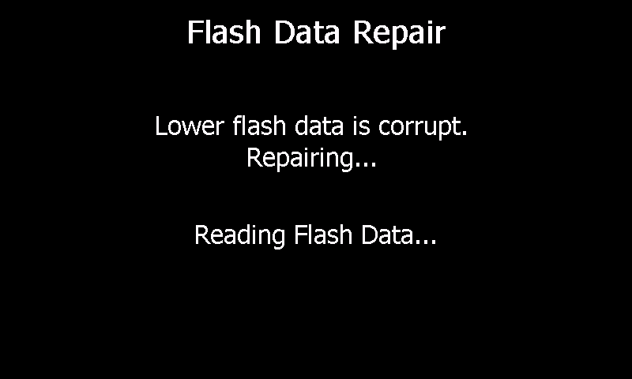

Screen 2: Writing Flash Data

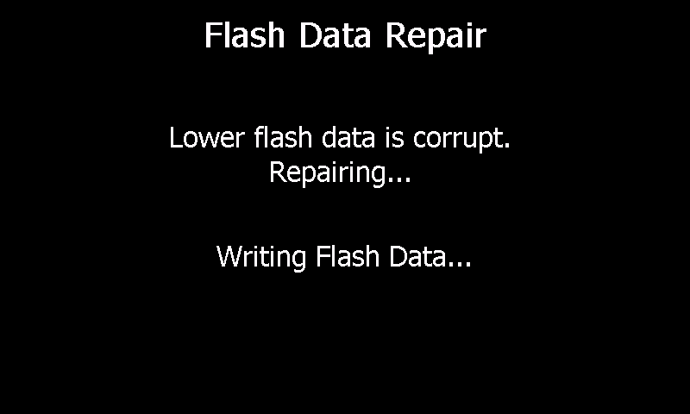

Screen 3: Verifying Flash Data

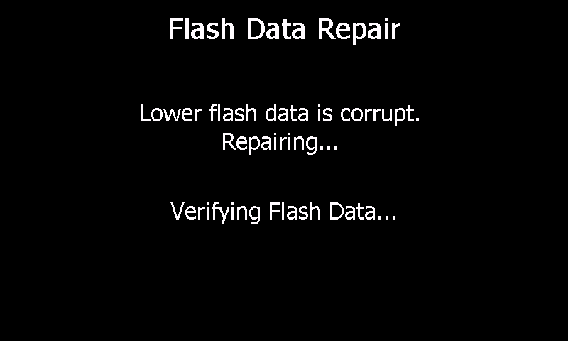

Screen 4: Repair Complete

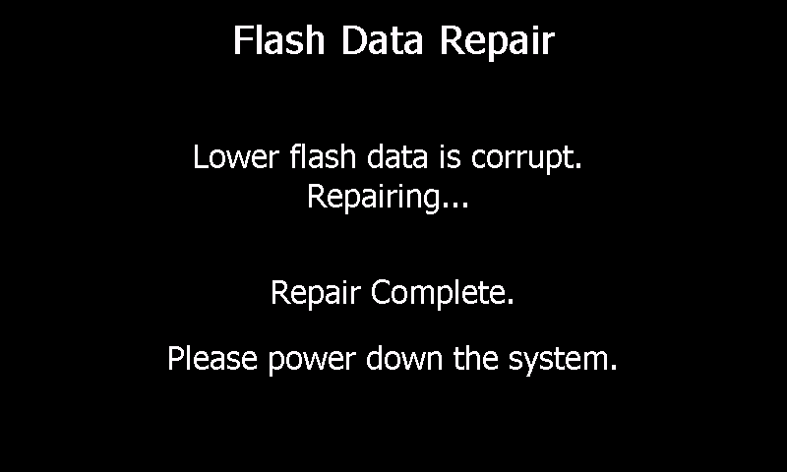

Screen 5: All Corrupt No Repair

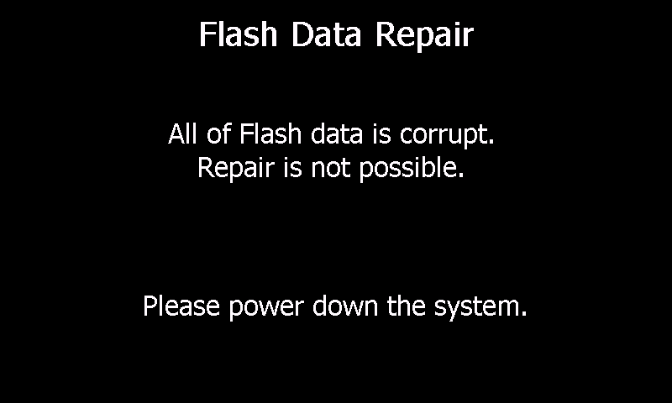

Screen 6: Read Failed

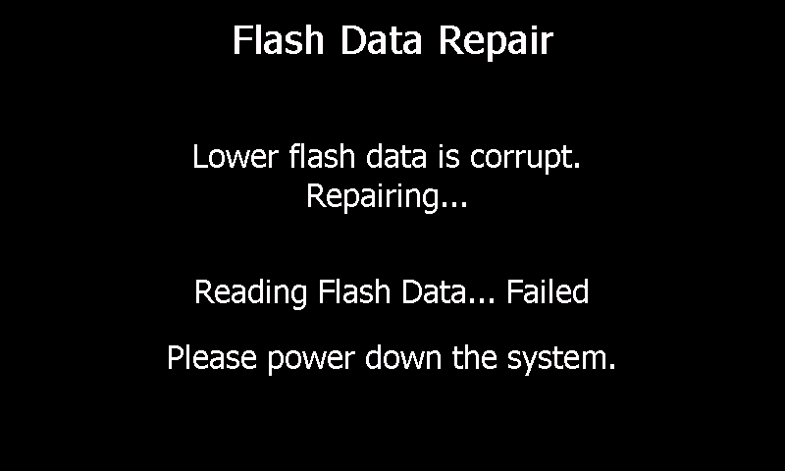

Screen 7: Write Failed

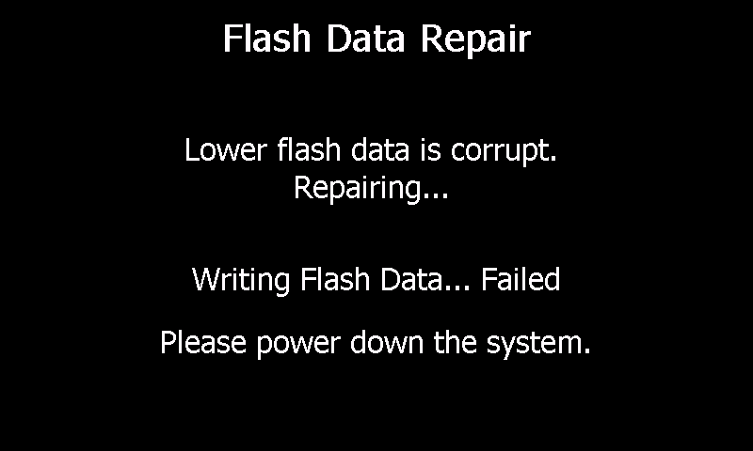

Screen 8: Verify Failed

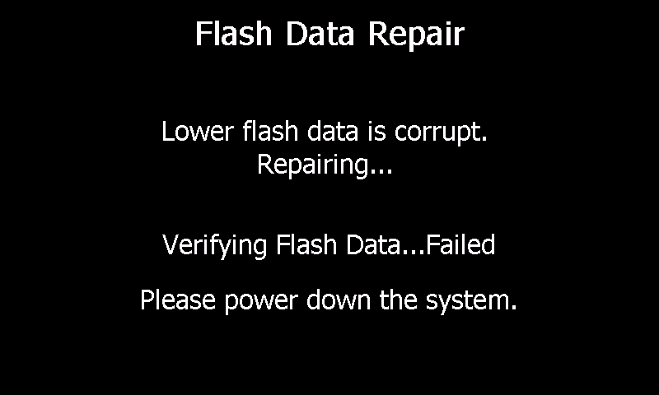

# Upgrading a System Using an Upgrade File

Upgrading a system is straightforward:

* Turn target system off
* Insert USB Flash Drive into any USB slot of the target device
* Turn target system on
* The system performs a test for the presence of a Serial Number.
* If a Serial Number has not been entered, then display a Keypad to enter the Serial Number.
* User must enter a numerical portion of the Serial Number.
* Once the system has a detected a stored Serial Number the system displays the serial number and provides the user with the choice of Done with software upgrade, Change the serial number, or Continue with software upgrade.
* If Continue with software upgrade is selected, a menu is presented giving the user the choice of canceling the upgrade, or proceeding with it.
* Informative messages are presented regarding the progress of the upgrade process
* Remove USB Flash Drive when indicated
* Power down system when indicated

Consult the references below for internal details of the upgrade process.

The USB Flash Drive can contain upgrade information for either or both of the System Software and the Motor Controller Software, in any order. The System Software is always upgraded, even if the upgrade software has the same version as the installed software. The Motor Controller Software, on the other hand, is only upgraded if the USB Flash Drive has a different version (earlier or later) than that on the Motor Controller.

There are six (6) categories of screens that are shown on the device:

1. Serial Number screens
2. Initiate Software Upgrade screens
3. System Software screens
4. Motor Controller Software screens
   1. Motor Controller Software versions are different
   2. Motor Controller Software versions are the same
5. Final screens
6. Top level error screens

In the screen shots below, please note that the version numbers shown are for illustration purposes only.

## Serial Number Screens

The Serial Number Screens consist of the Check Serial Number Screen and Enter Serial Number Screen. At the start of software upgrade the Check Serial Number Screen is displayed.

### Check Serial Number Screen

The Check Serial Number Screen is the first Screen displayed during Software Upgrade. Upon initial display of the screen, the system reads the previously stored Serial Number from Non-volatile memory and confirms a valid serial number string has been stored. If a valid serial number string is not returned the system proceeds to Enter Serial Number Screen as an overlay on top of the Check Serial Number screen.

If a valid Serial Number string is retrieved, the Check Serial Number screen displays the Serial Number and prompts the user to verify the Serial Number matches the one on the back of the unit. The screen presents the user with three (3) buttons:

1. Done – The user accepts the serial number and does not wish to proceed to software upgrade. Pressing this button will cause the user to be prompted to remove the USB Key.
2. Change – The user wishes to change the serial number. Pressing this button causes the Enter Serial Number screen to be displayed.
3. Continue – The user accepts the serial number and wishes to continue to software upgrade. Pressing this button will transition the display to Initiate Software Upgrade Screen.

Screen 500: Check Serial Number

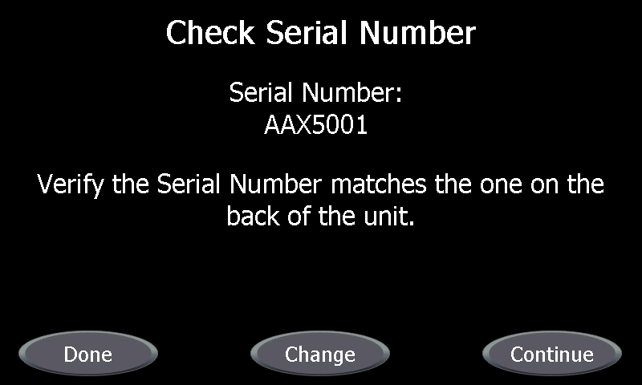

### Check Serial Number Remove USB Screen

If the user selects the Done button the buttons are removed from the Check Serial Number screen and replaced by the prompt to “Please remove the USB drive.”, screen 530. The system will remain in this state until the user removes the USB drive from the rear of the system or the system is powered down.

Screen 510: Check Serial Number Remove USB Drive

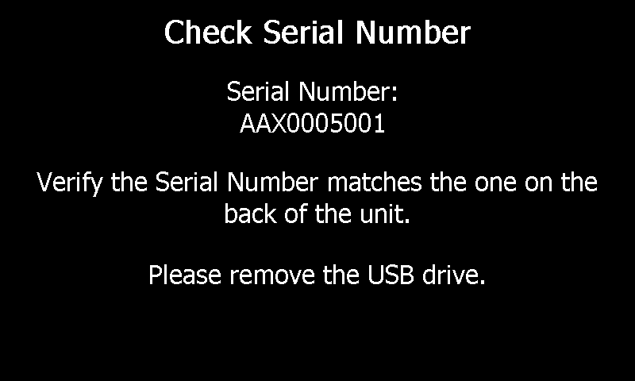

### Check Serial Number Power Down Screen

Once the system detects the removal of the USB key from the rear of the unit the text “Please remove the USB drive.” Is replaced by “Please power down the system”, screen 520. The system will remain in this state until the system is powered down.

Screen 520: Check Serial Number Power Down

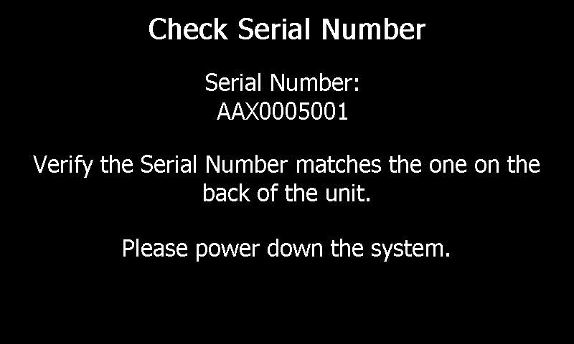

When the system is powered back on after the Check Serial Number is reported Done, the software versions in the system are unchanged from prior to the Check Serial Number.

### Enter Serial Number Screen

The Enter Serial Number Screen provides a keypad to enter a DYONICS POWER II Serial Number consisting of a prefix “AAX” and a numerical value from “5001” to “9999999” and will appear as “AAX5001” to “AAX999999999”. The numerical value may be entered with leading zeros such as “0083015” and will appear as “AAX0083015”.

Upon Pressing the Enter button the software will confirm that a valid Serial Number has been entered. If the entered Serial Number is not valid the Enter Serial Number screen will remain on the display until the device is powered off.

If a valid Serial Number has been entered the value is stored in Non-volatile memory as a NULL terminate string followed 1 byte CRC of the string. The Enter Serial Number Screen is erased and the Check Serial Number Screen is uncovered.

When the Enter Serial Number Screen is initially displayed, the system checks Non-volatile memory for a valid Serial Number. If a valid Serial Number is not retrieved the Enter Serial Number Screen displays only the “AAX” prefix, screen 530.

Screen 530: Enter Serial Number no Valid Serial Number

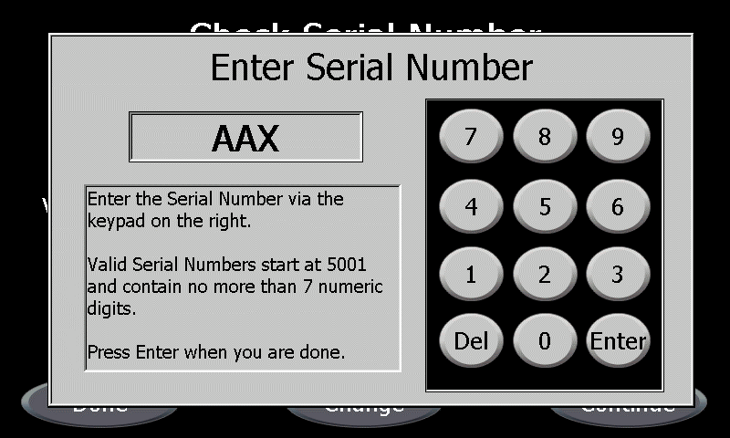

I

If a valid Serial Number, as an example “AAX5001” is retrieved the Enter Serial Number Screen will be displayed with the Serial Number, screen 540.

Screen 540: Enter Serial Number with Valid Serial Number

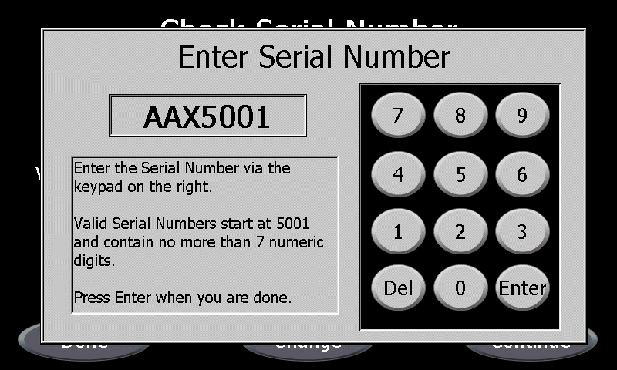

## Initiate Software Upgrade Screens

On the following screens, pressing the CANCEL button causes the upgrade to immediately exit with Cancelled condition Software Upgrade Update Cancelled. Pressing START proceeds to either the System Software Screens or the Motor Controller Software Screens. An Error Screen is always followed by Final Screen 410.

### Motor Controller Software Versions Are Different

Screen 100: Cancel Start Motor Controller Versions Different

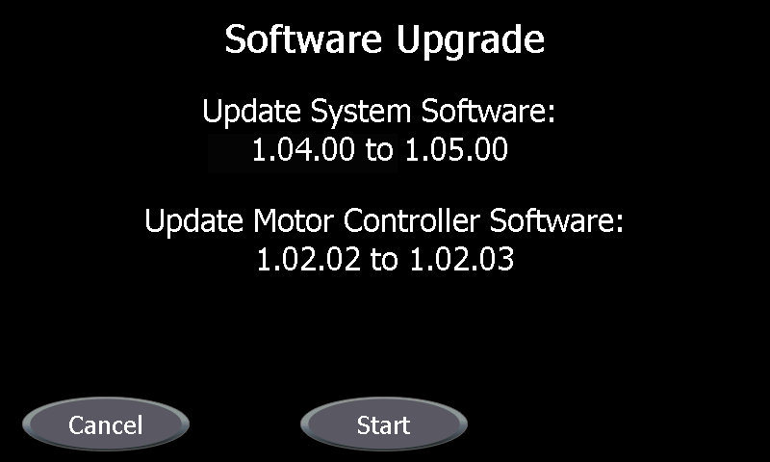

### Motor Controller Software Versions Are the Same

Screen 110: Cancel Start Motor Controller Versions Same

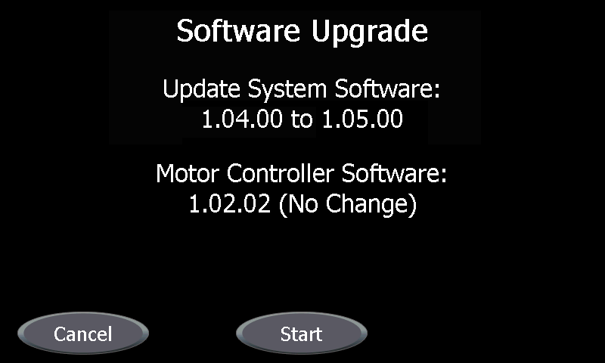

### Software Upgrade Update Cancelled

Upon pressing the Cancel button on the Software Upgrade Screen, the Cancel and Start buttons are removed from the screen and the screen is updated with the text “Update Cancelled. Please remove the USB drive.”, Screen 120. Once the system detects the removal of the USB key from the rear of the unit the text “Please remove the USB drive.” Is replaced by “Please power down the system.”, Screen 130.

When the system is powered back on after the Software Update cancellation, the software versions in the system are unchanged from prior to the Software Upgrade.

Screen 120: Update Canceled Remove the USB drive

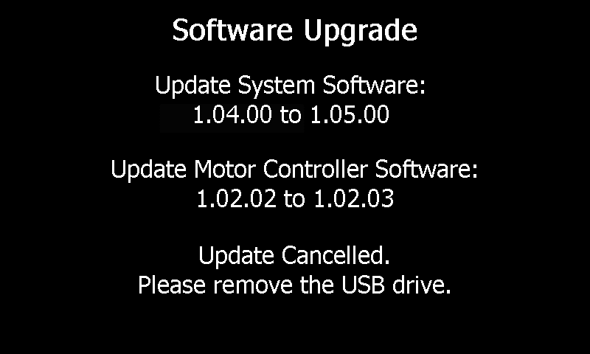

Screen 130: Update Canceled Power Down the System

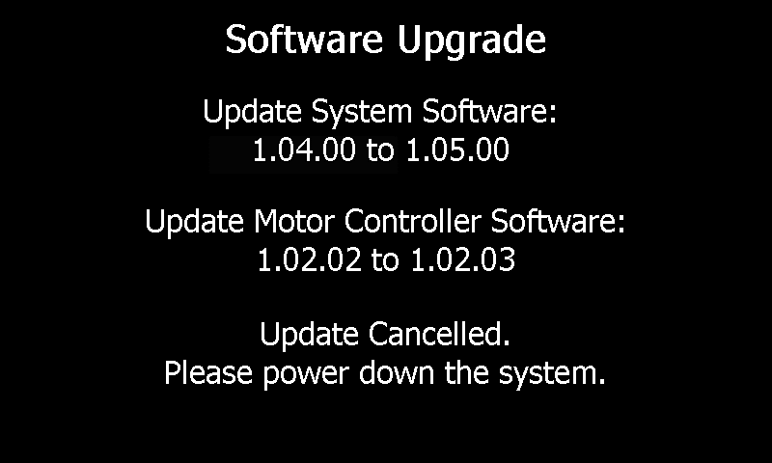

## System Software Screens

These are status screens that automatically progress from one screen to the next.

The following screen shots represent a detailed mode of display. (This is achieved by inserting a Factory Mode USB key in the back of the unit). The default mode of display only will show screens 201, 202, 204.

### Normal Screens

Screen 200: Reading System Image Header

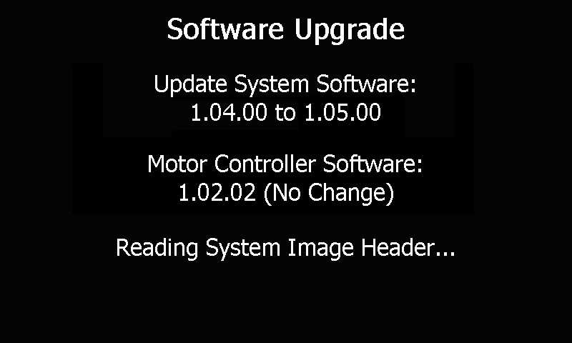

Screen 201: Reading System Image Data

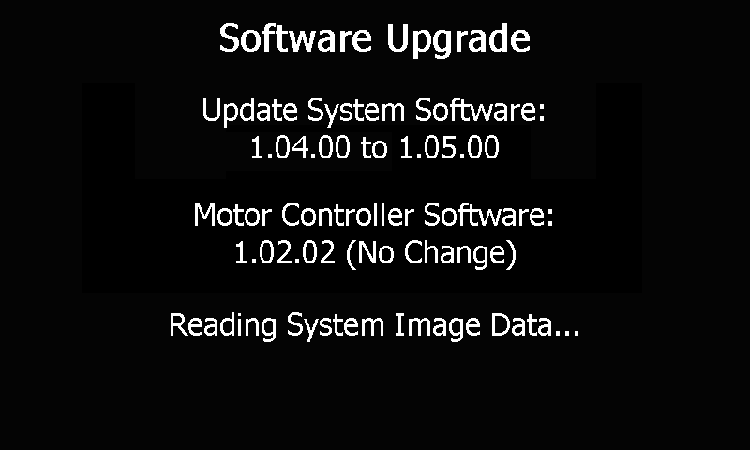

Screen 202: Writing Lower Flash Data

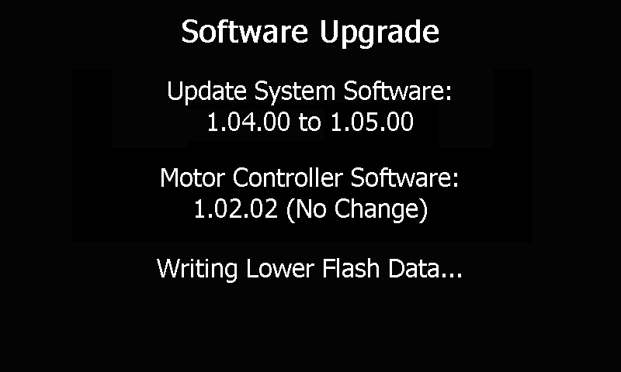

Screen 203: Verifying Lower Flash Data

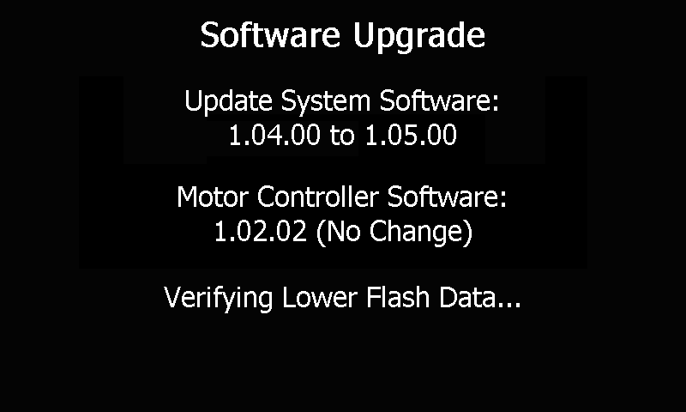

Screen 204: Writing Upper Flash Data

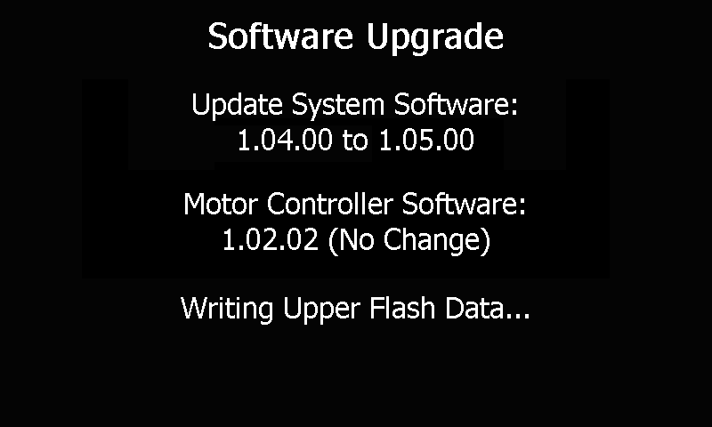

Screen 205: Verifying Upper Flash Data

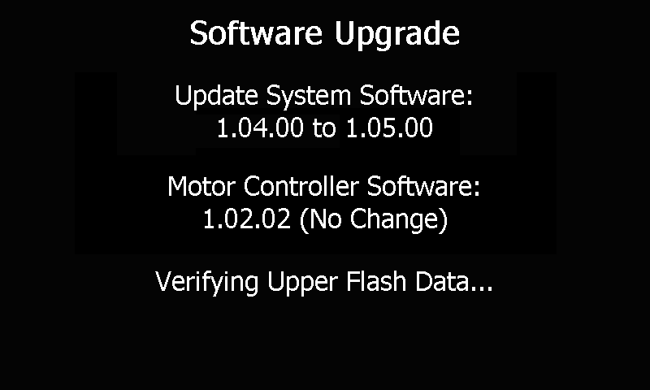

### Error Screens

Screen 210: Reading System Image Header Failed

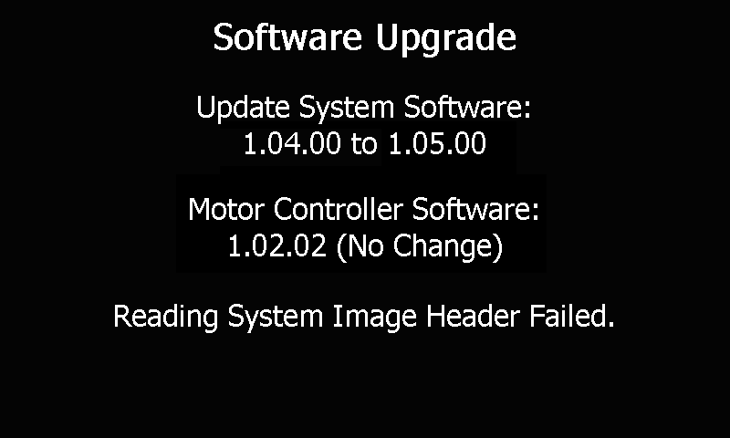

Screen 211: Invalid System Image Header CRC

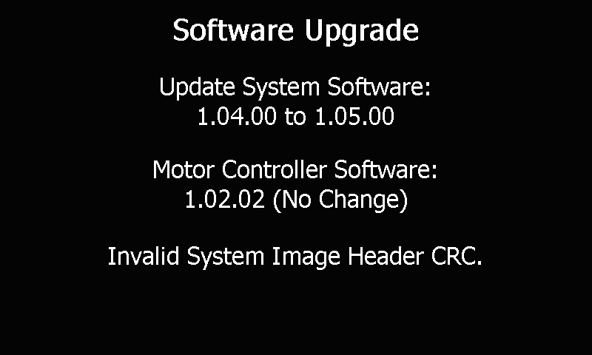

Screen 212: Error Allocating Memory for System Image

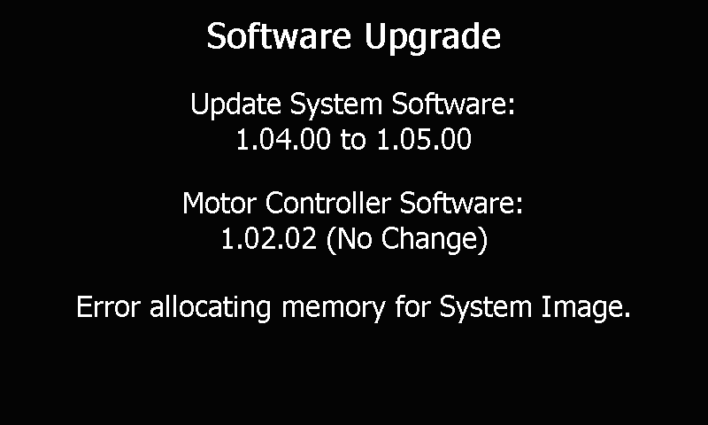

Screen 213: Reading System Image Data Failed

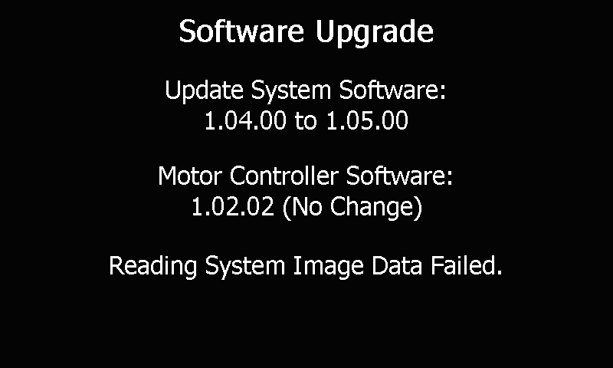

Screen 214: Invalid Splash Data CRC

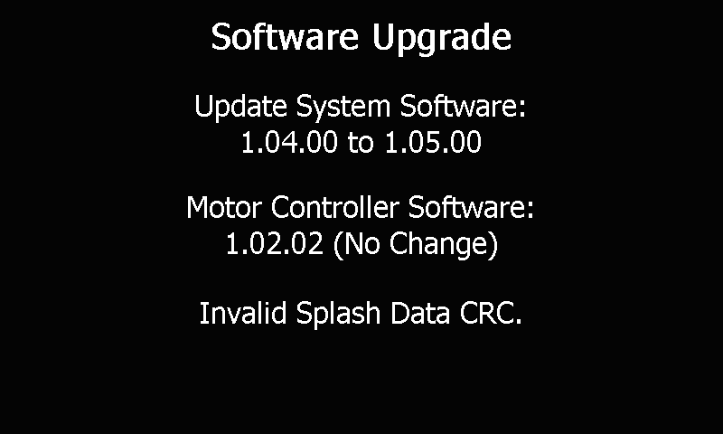

Screen 215: Invalid System Data CRC

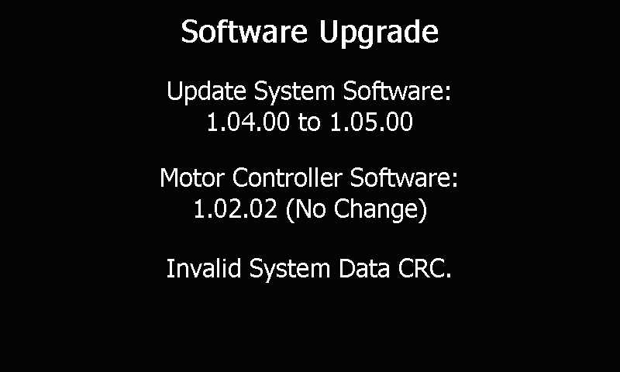

## Motor Controller Software Screens

These are status screens that automatically progress from one screen to the next.

The following screen shots represent a detailed mode of display. (This is achieved by inserting a Factory Mode USB key in the back of the unit). The default mode of display only will show screen 301.

### Motor Controller Software Versions Are Different

Screen 300: Reading Motor Controller Image Header

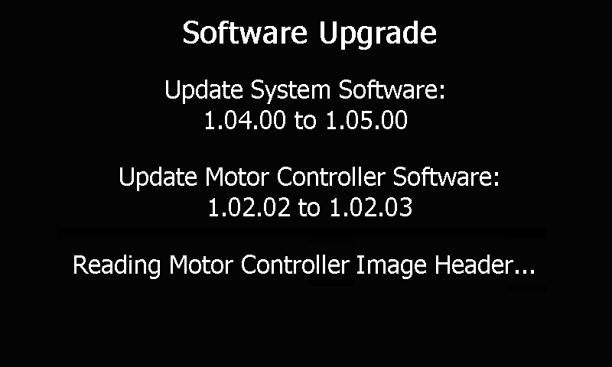

Screen 301: Updating Motor Controller Program Flash

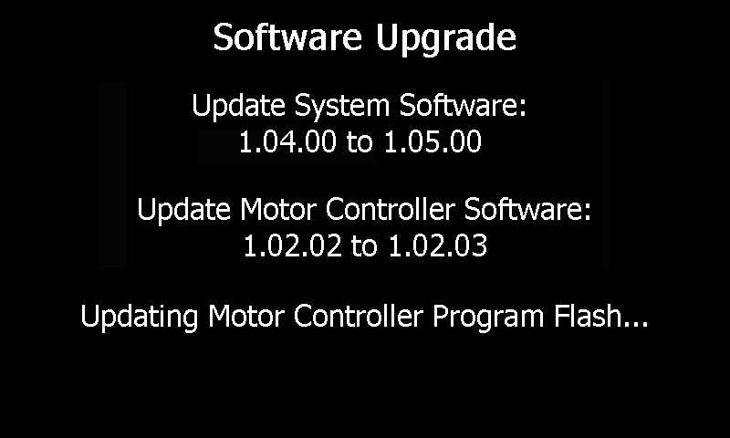

Screen 302: Updating Motor Controller Data Flash

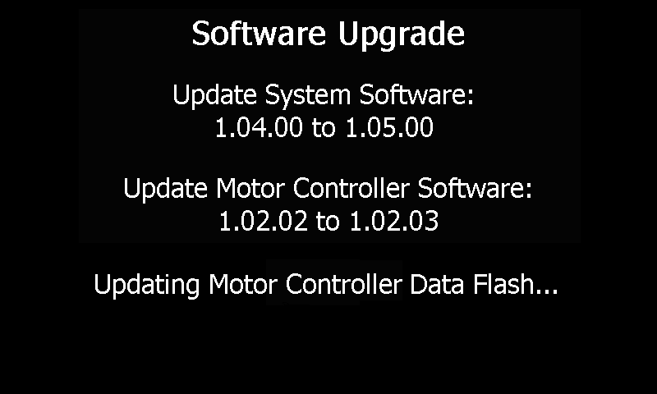

### Motor Controller Software Versions Are the Same

Screen 310: Skipping Motor Controller Image Header

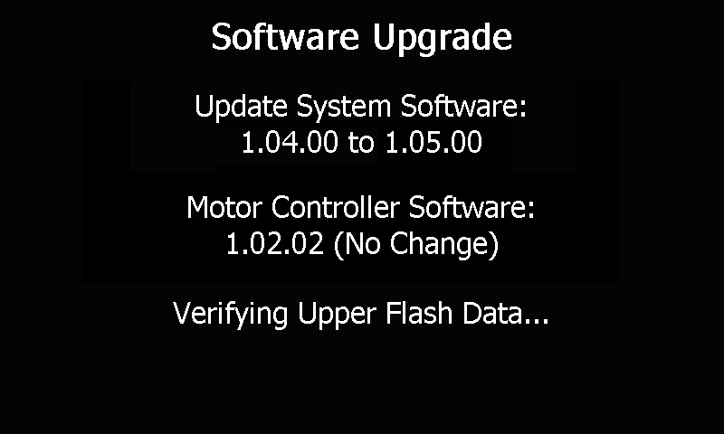

### Error Screens

Screen 320: Reading Motor Controller Header Failed

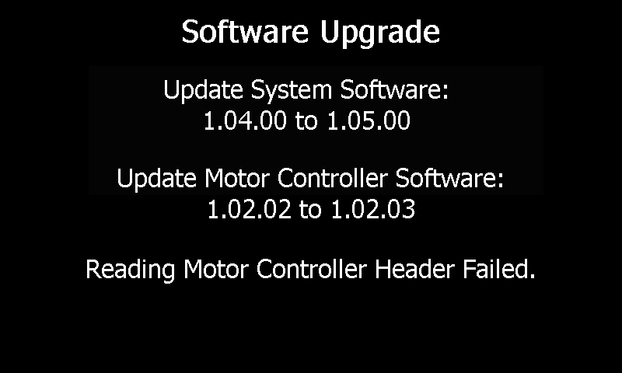

Screen 321: Reading Motor Controller Program Flash Failed

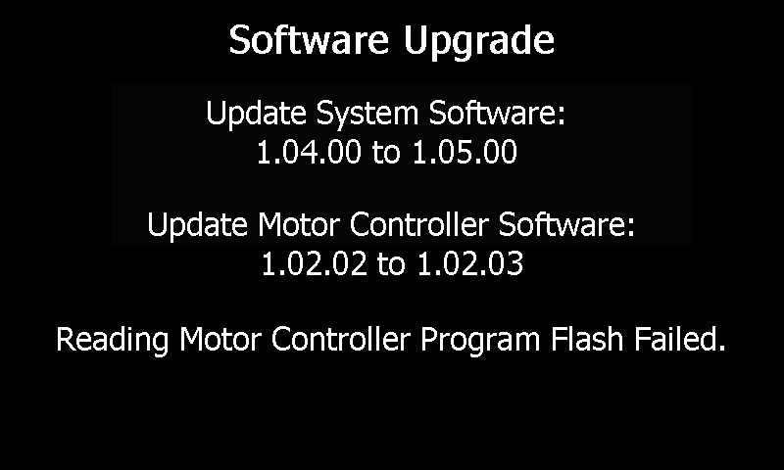

Screen 322: Reading Motor Controller Data Flash Failed

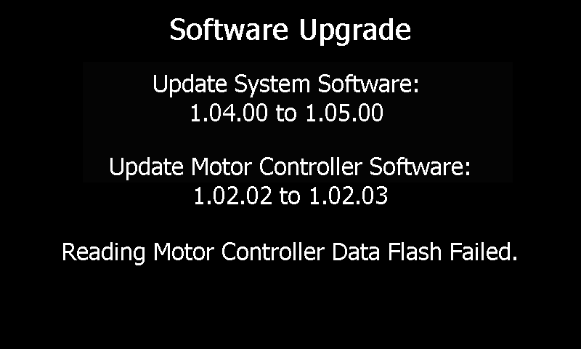

Screen 323: Invalid Motor Controller Image Header CRC

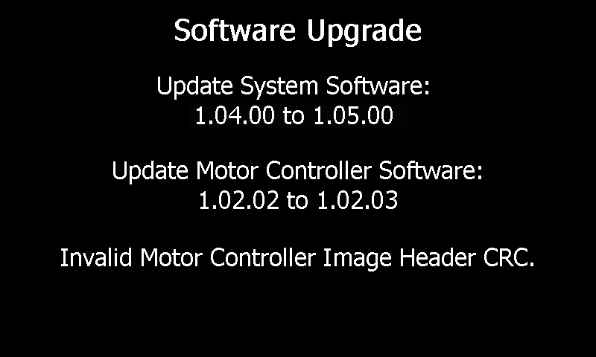

Screen 324: Writing Motor Controller Program Flash Failed

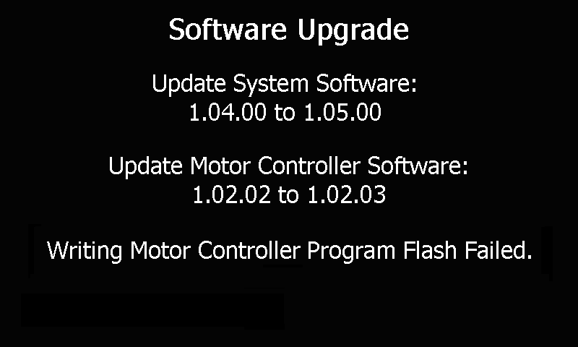

Screen 325: Writing Motor Controller Data Flash Failed

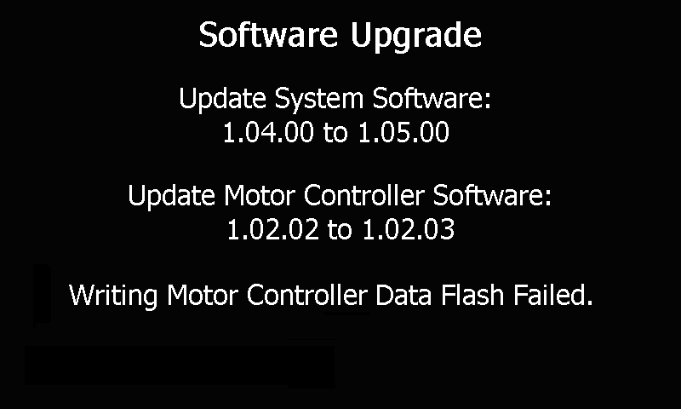

## Final Screens

The following screen shots represent a detailed mode of display. (This is achieved by inserting a Factory Mode USB key in the back of the unit). The default mode of display only will show screens 400, 401, 410, 411.

### Final Screens with No Upgrade Errors

Screen 400: Update Complete Please Remove the USB Drive

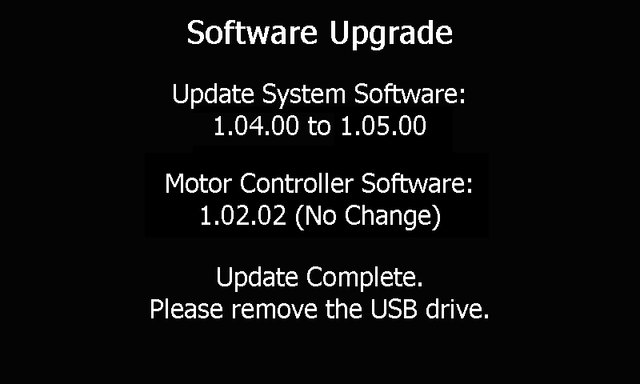

Screen 401: Update Complete Please Power Down the System

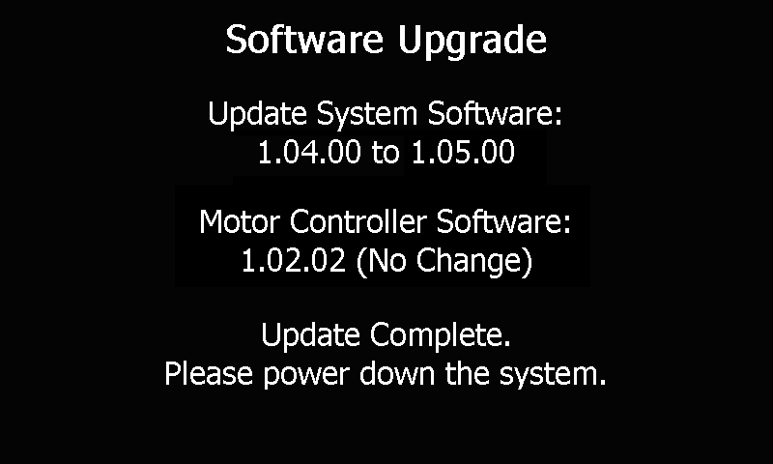

### Final Screens with Upgrade Errors

Screen 410: Update Failed Please Remove the USB Drive

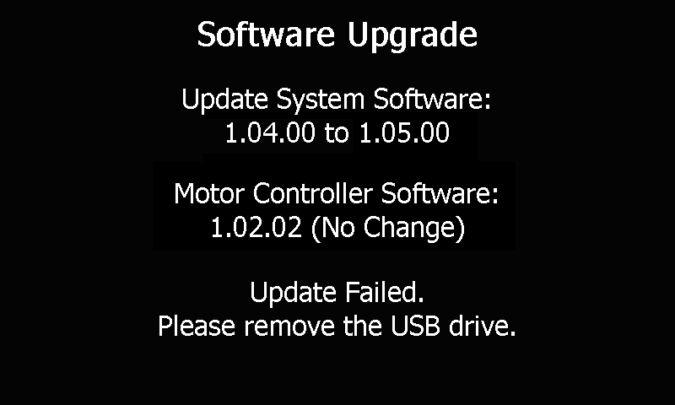

Screen 411: Update Failed Please Power Down the System

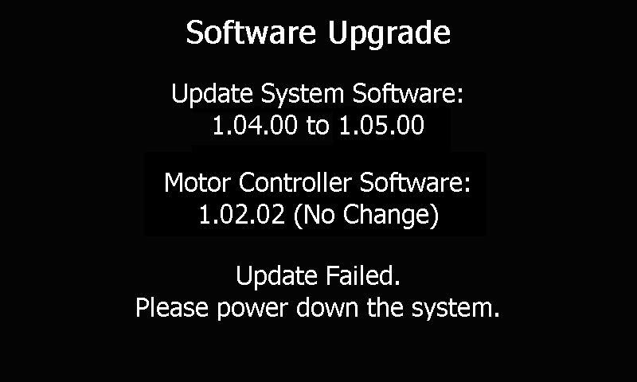

## Top Level Error Screens

Screen 500: Unknown Image Header Type

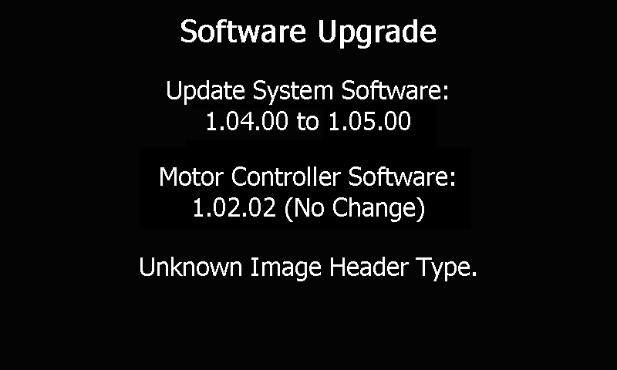

## Example Screen Sequences and User Actions

### Invalid Serial Number Software Update Successful

Invalid Serial number, USB Flash Drive Has System Software, followed by Motor Controller Software, Versions in System Are Different, No Update Errors.

530 Enter Serial Number press Enter, 500, Press Continue, 100, Press START on screen 100, 200, 201, 202, 203, 204, 205, 300, 301, 302, 400, Remove USB Flash Drive from system, 401, Power Down System

### Valid Serial Number Software Update Successful

Valid Serial number, USB Flash Drive Has System Software, followed by Motor Controller Software, Versions in System Are Different, No Update Errors.

500, Press Continue, 100, Press START on screen 100, 200, 201, 202, 203, 204, 205, 300, 301, 302, 400, Remove USB Flash Drive from system, 401, Power Down System

### Valid Serial Number Software Update Errors

USB Flash Drive Has System Software, followed by Motor Controller Software, Versions in System Are Different, Update Error.

500, Press Continue, 100, Press START on screen 100, 200, 201, 213, 410, Remove USB Flash Drive from system, 411, Power Down System

### Valid Serial Number System Controller Only Update Successful

USB Flash Drive Has System Software, followed by Motor Controller Software, Versions in System Are Same, No Errors.

500, Press Continue, 110, Press START, 200, 201, 202, 203, 204, 205, 310, 400, Remove USB Flash Drive from system, 401, Power Down System

### Valid Serial Number Motor Controller System Controller Update Successful

USB Flash Drive Has Motor Controller Software, followed by System Software, Versions in System Are Different, No Errors.

500, Press Continue, 110, Press START, 300, 301, 302, 200, 201, 202, 203, 204, 205, 400, Remove USB Flash Drive from system, 401, Power Down System

### Serial Number Update Only

Invalid Serial number, No Update Errors.

530 Enter Serial Number press Enter, 500, Press Done, 510, Remove USB Flash Drive from system, 520, Power Down System

# References

Operation of Motor Controller Bootstrap Code doc

Windows CE Flow.doc